**Final Assignment Module – Mohammed Abdin**

**Submission Instructions:**

Your submission for this assignment should be a Word document that includes the following screenshots, each labeled for the step that the screenshot represents:

1. Provide a screenshot to show that you were able to open the Final_Assignment_Module_12 folder in VS Code.

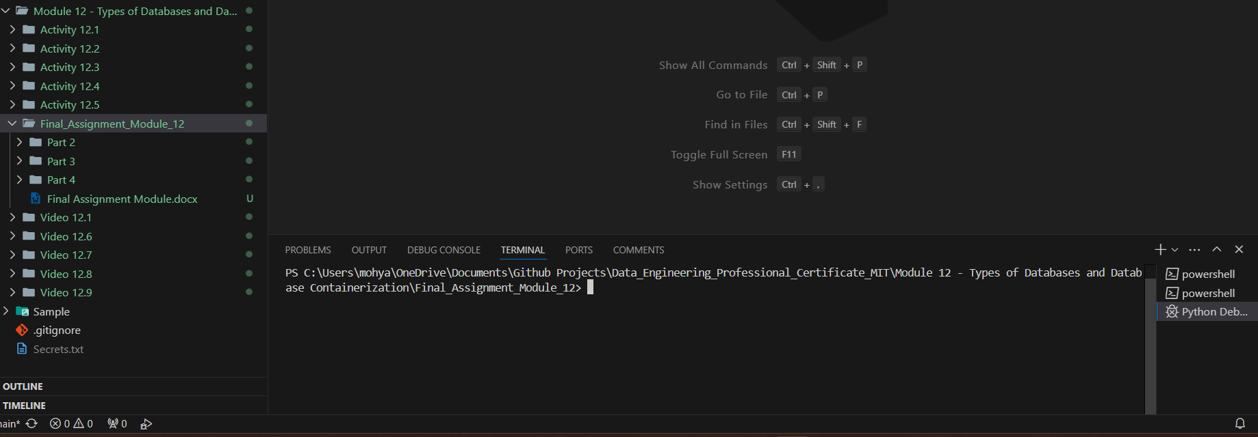

1. 1. Provide a screenshot to show that you successfully ran the command to initialize the *driver* for Part 2 in VS Code.

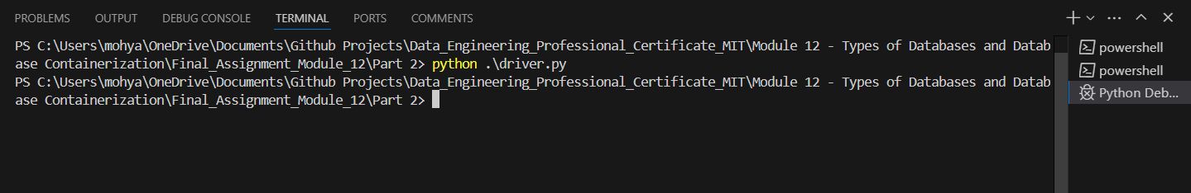

* 1. Provide two screenshots. The first screenshot should show the code demonstrating which data you defined, including the required three entries. The second screenshot should show that you successfully ran the `create.py` file.

First screenshot:

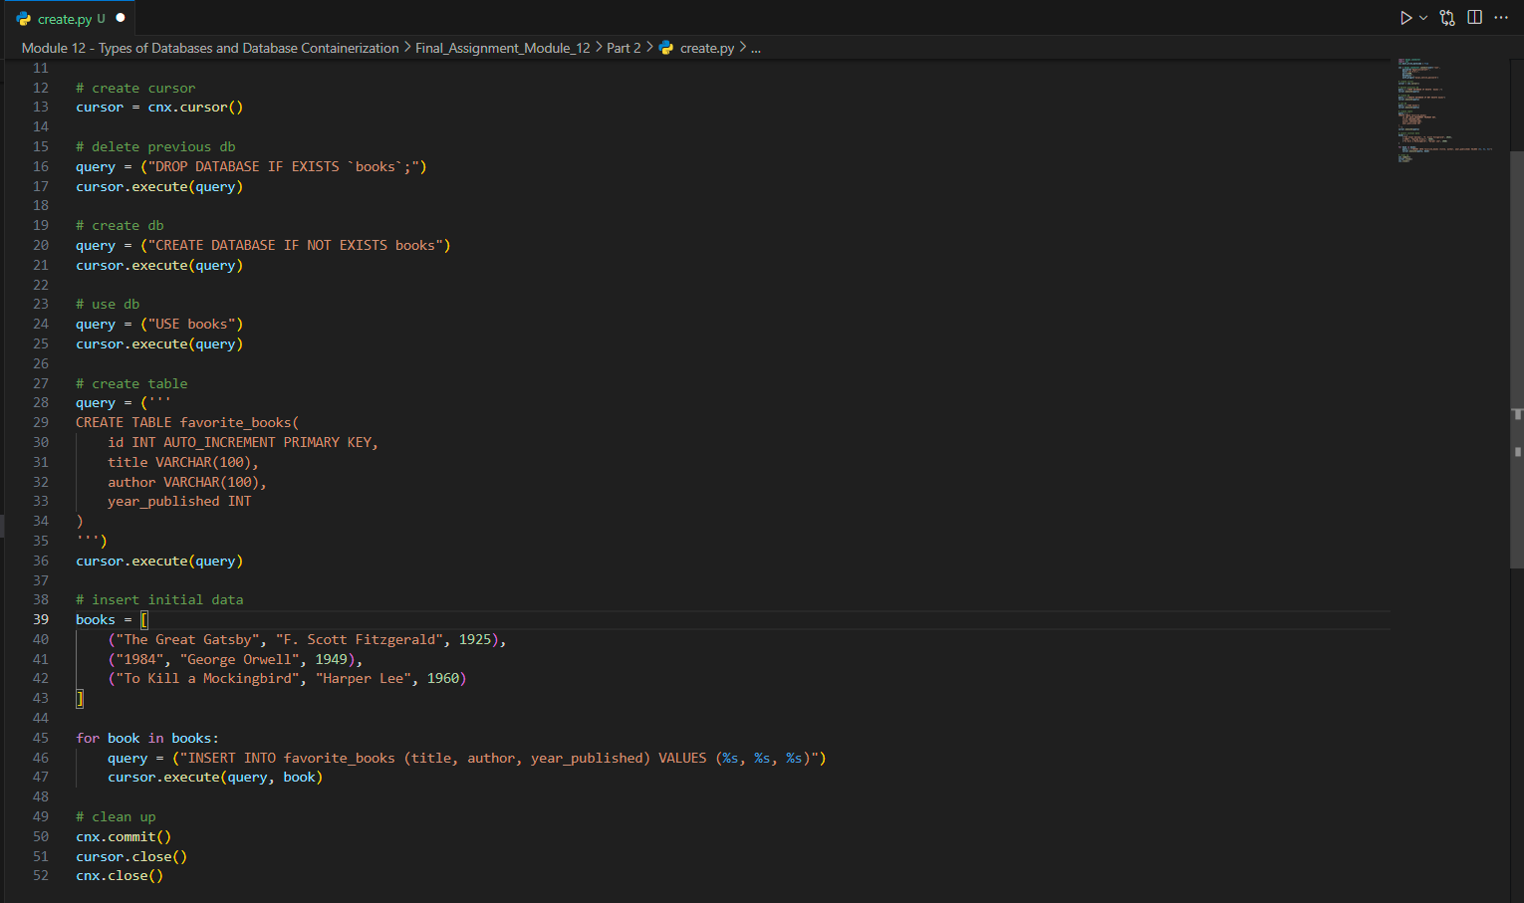

Second screenshot

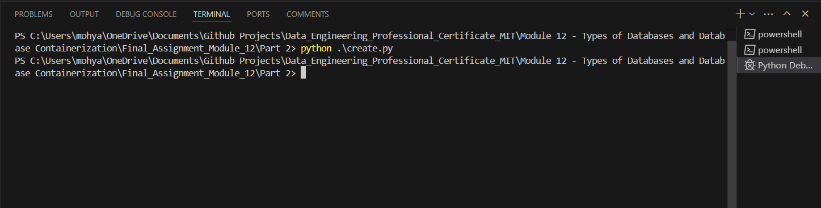

* 1. Provide a screenshot of your Terminal window to show that your data is visualized correctly, that you ran the correct commands, and the correct entry is displayed.

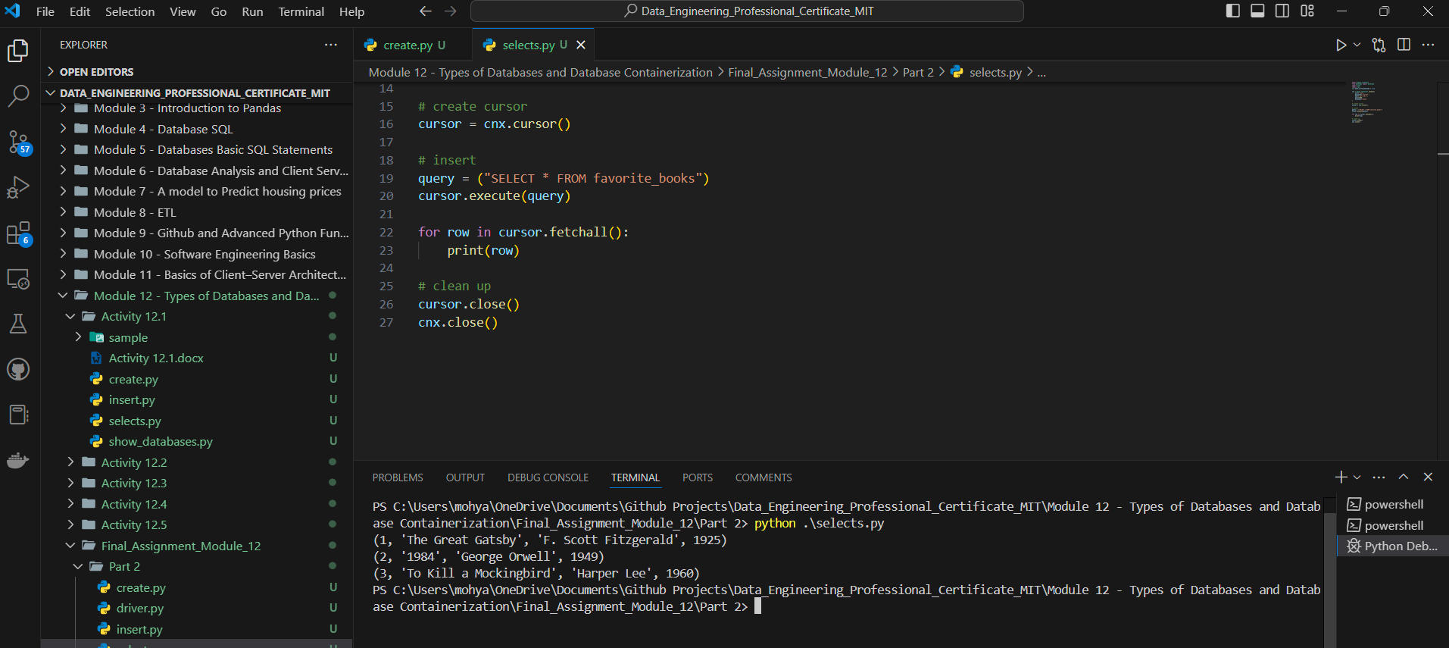

* 1. Provide a screenshot to show that you successfully created the *container* named ‘final_assignment’ in Docker using port 3300.

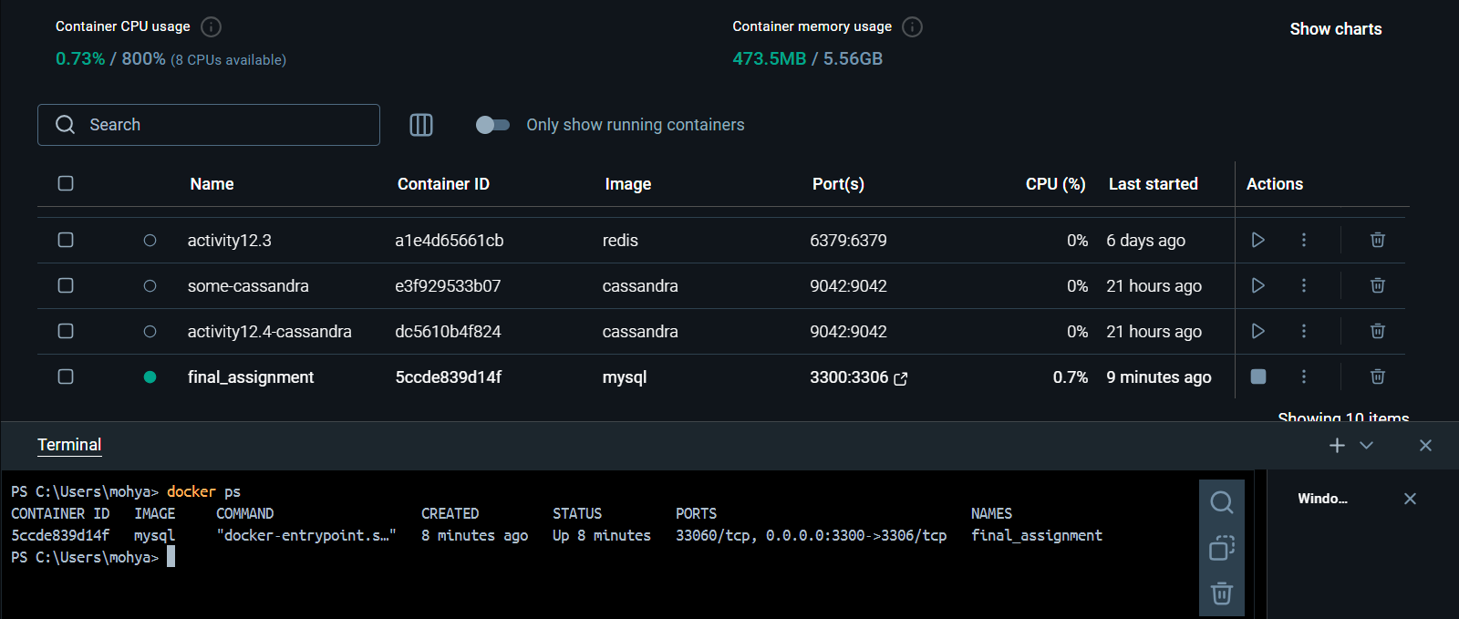

1. 1. Provide a screenshot to show that you successfully ran the command to initialize the *driver* for Part 3 in VS Code.

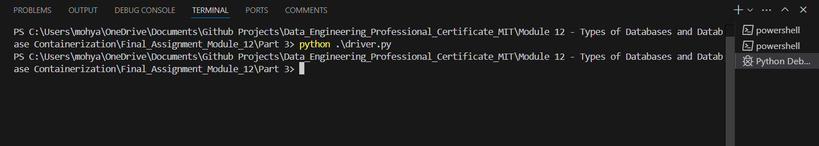

* 1. Provide two screenshots: The first screenshot should show that you successfully ran the command to create the “final_assignment_part3” *container* in your Terminal window. The second screenshot should show that the *container* you created is active on Docker.

First screenshot:

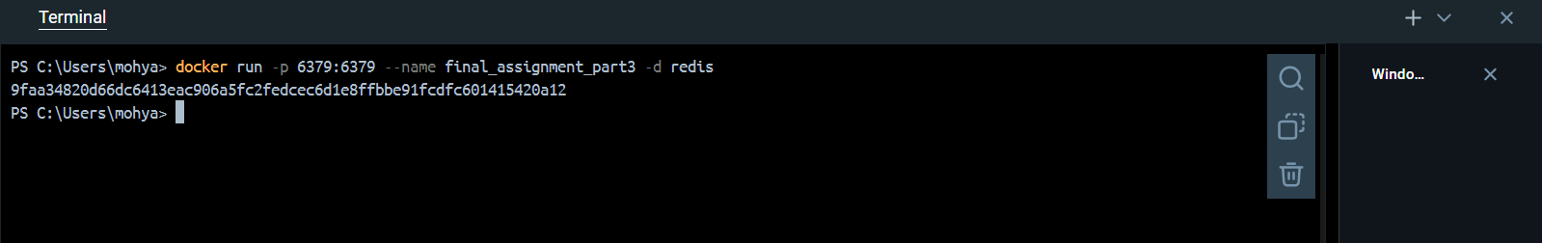

Second screenshot:

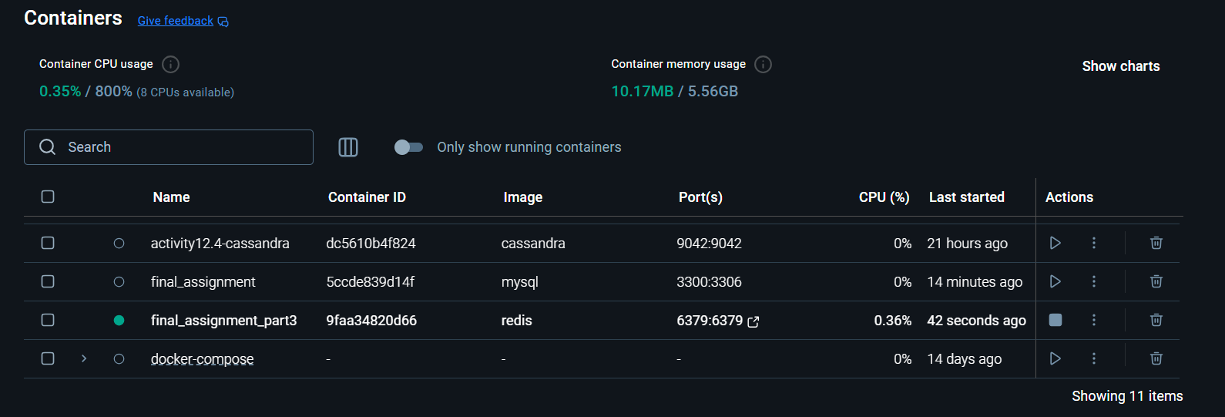

* 1. Provide a screenshot to show that you successfully used the Redis *method*, mset, to create a *dictionary*, r, with *keys* equal to “Milk” and “Bread” and corresponding values equal to “Lactose” and “Gluten”.

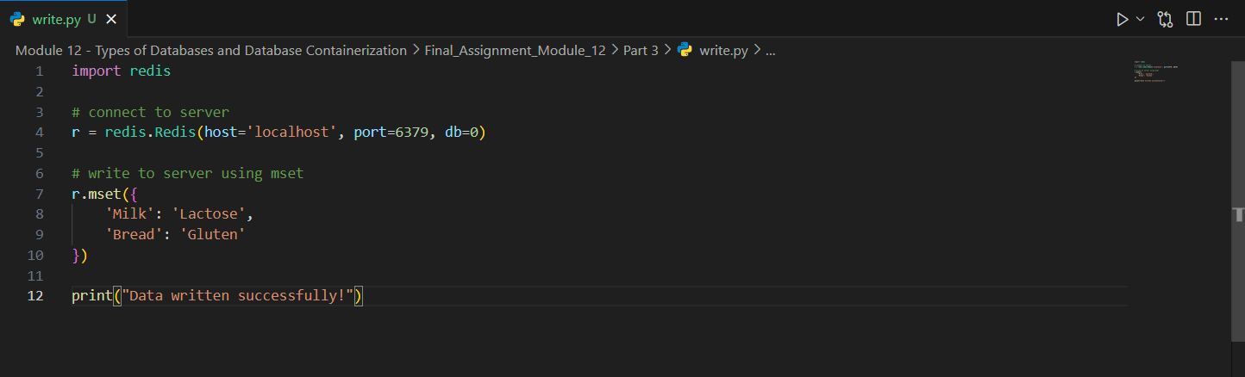

* 1. Provide a screenshot of your Terminal window running the write.py file to show that your syntax does not contain any errors.

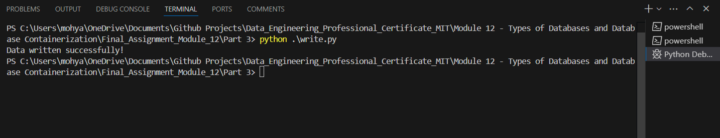

* 1. Provide a screenshot of the read.py file to show your updated code after you used the Redis *method*, get, to read all values in r.

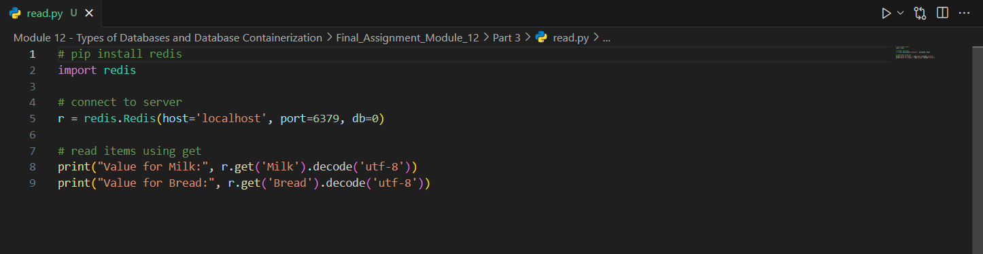

* 1. Provide a screenshot of your Terminal window to show that your code prints the *dictionary* values correctly in the read.py file.

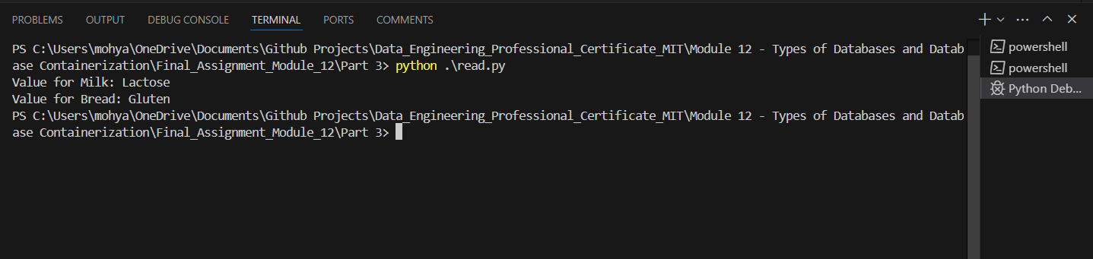

1. 1. Provide a screenshot to show that you successfully ran the command to open the starter file for Part 4.

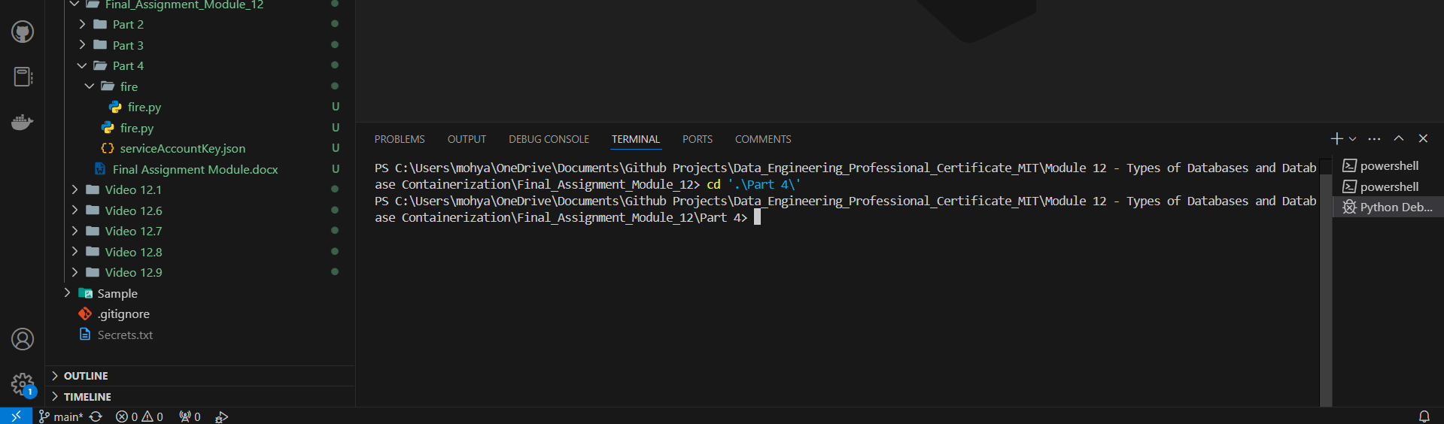

* 1. Provide a screenshot to show that you created a new project called “Assignment-Module12” in Firebase.

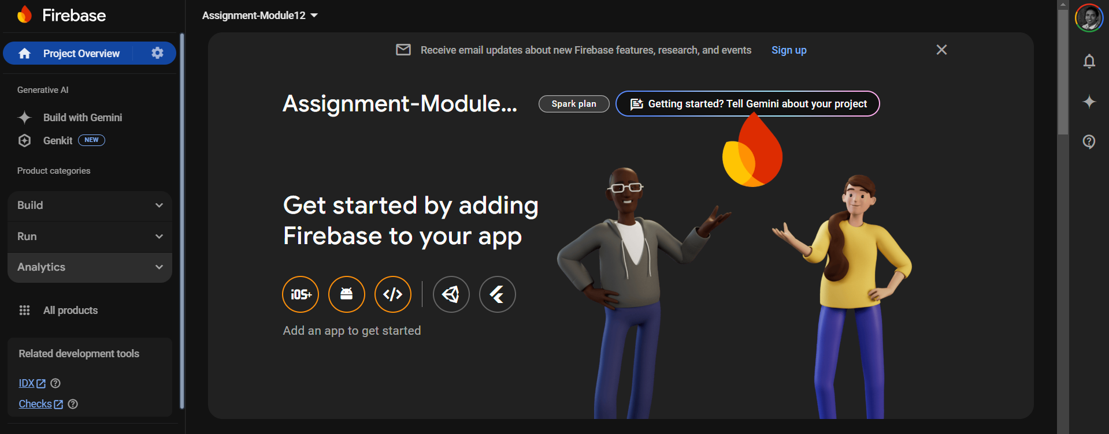

* 1. Provide two screenshots: One screenshot should show that you navigated to the correct page in Firebase to obtain the private *key*, and one screenshot should show that you copied the private *key* file correctly into the serviceAccountKey.json file. Feel free to blur your private *key* in the screenshots.

-First Screenshot:

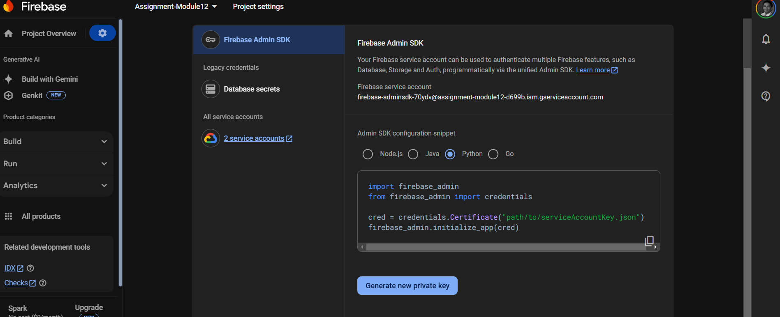

-Second Screenshot

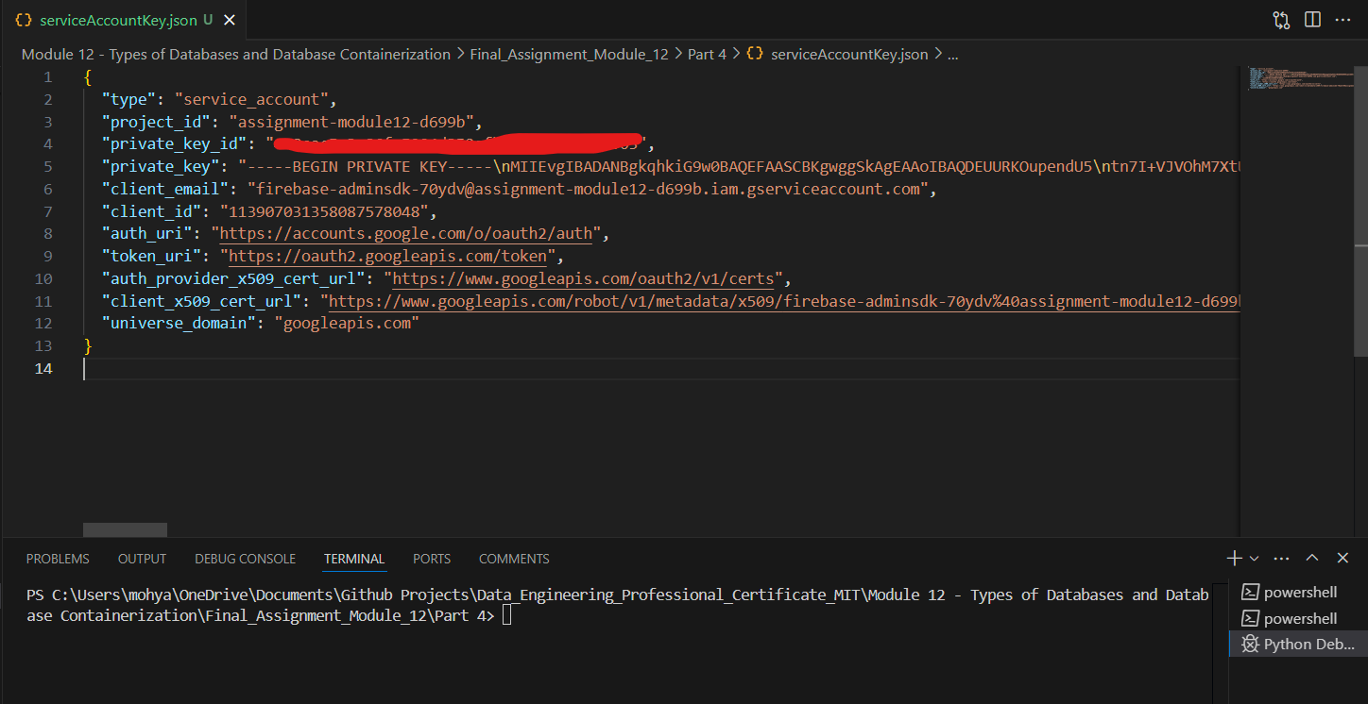

* 1. Provide a screenshot to show that you created an empty Realtime database for your project in Firebase.

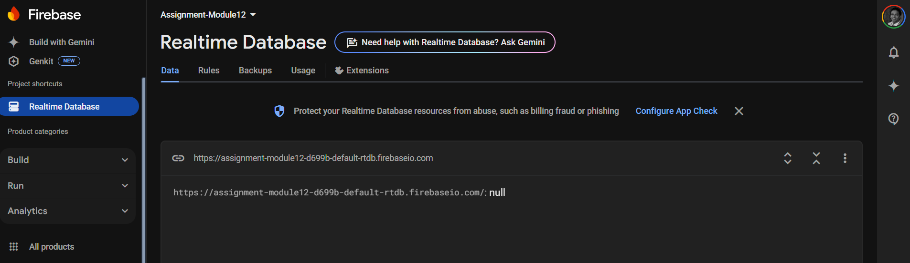

* 1. Provide a screenshot to show that you updated the databaseURL field in the fire.py file in VS Code with the URL that you copied.

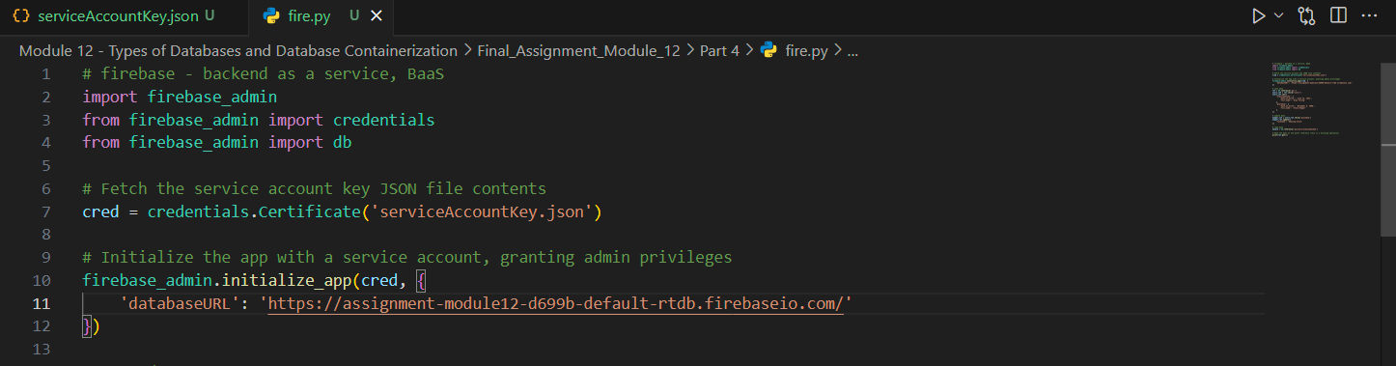

* 1. Provide a screenshot to show that you updated two entries in your database in the fire.py file.

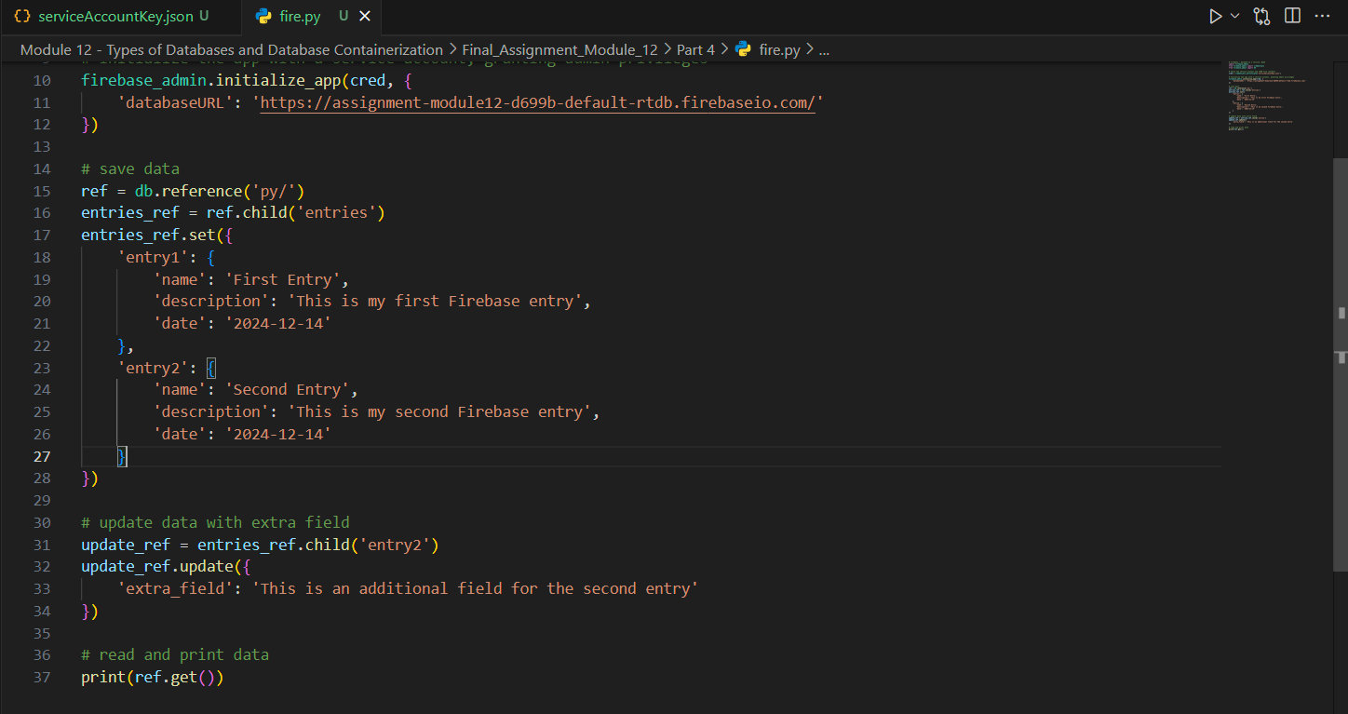

* 1. Provide a screenshot of your Terminal window to show that you ran the correct command to write to your database in Firebase.

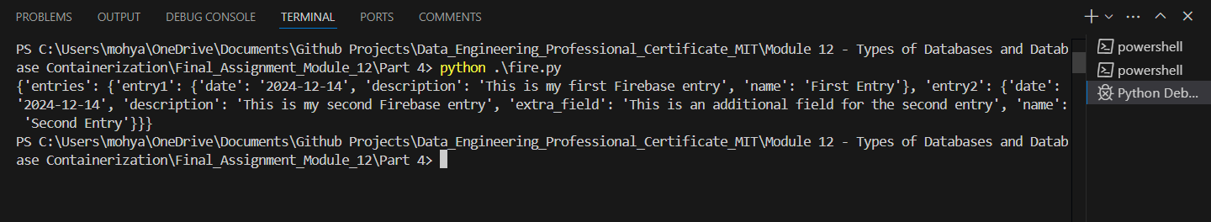

* 1. Provide a screenshot from Firebase to show that your database has been written as expected.

